CN LAB 4

**CS21B2028**

**NITIN REDDY K**

Server program with threads, where each thread can handle a single client.  
Ensure the server gets connected to multiple clients.  
All the client messages are to be displayed on the server.  
Provide a mechanism to disconnect the client.

**Server Code :**

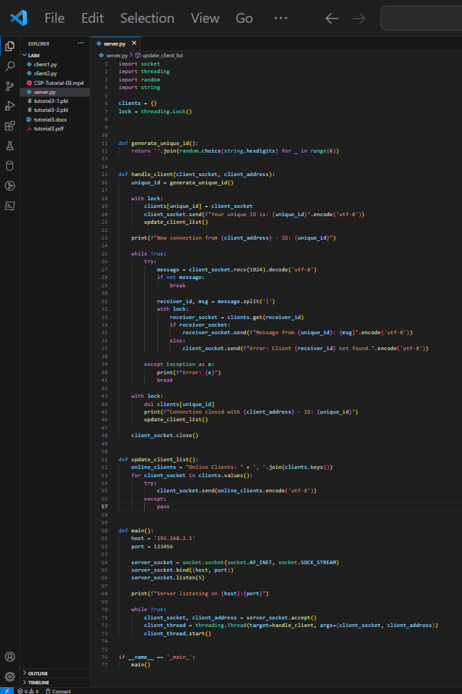

**Client Code:**

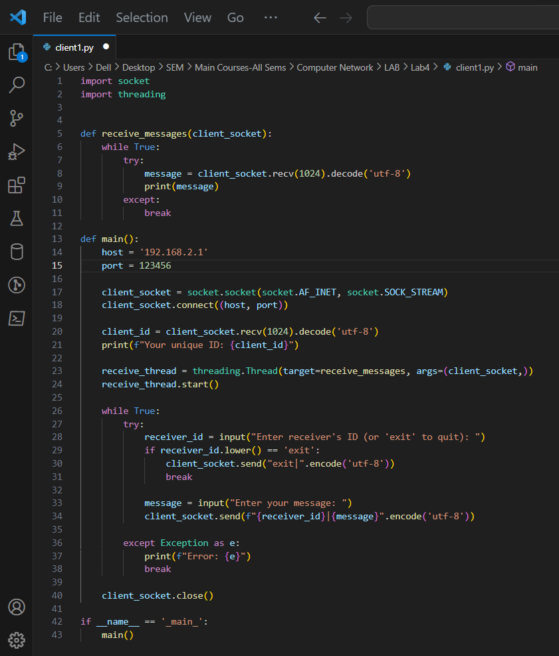

**Multiple Client Communication:**

